The customer file and vendor file has two Icons that provide for unlimited contacts.
First, you must add codes before adding new contacts.

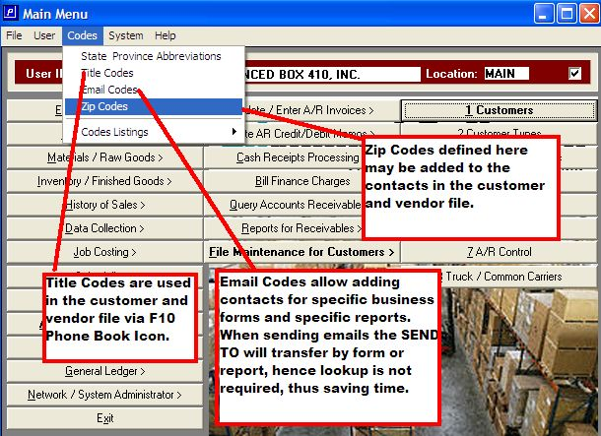

Next, click the Phone Book and Address Book to define unlimited contacts.
This becomes your company wide address book. Hence, all contacts and emails can be stored in one database.
Microsoft explorer will allow each computer a different database which are not shared and is a problem.
With the Advanced Software Contacts, you can build a single database that the entire company can share.

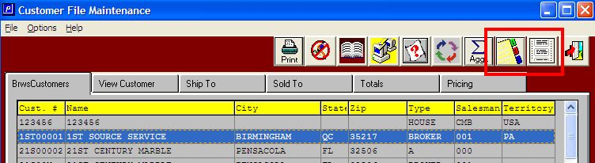

The Title Code imports from the Codes File and emails may be sent to multiple contacts by specific forms.
Multiple contacts can get a quote form. Other contacts will receive invoices or statements.
Still other contacts may be assigned to receive customer inventory reports.

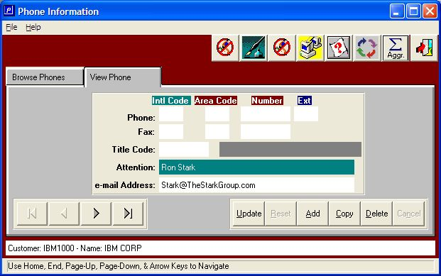

The Fountain Pen Icon allows unlimited notes fro each contact.

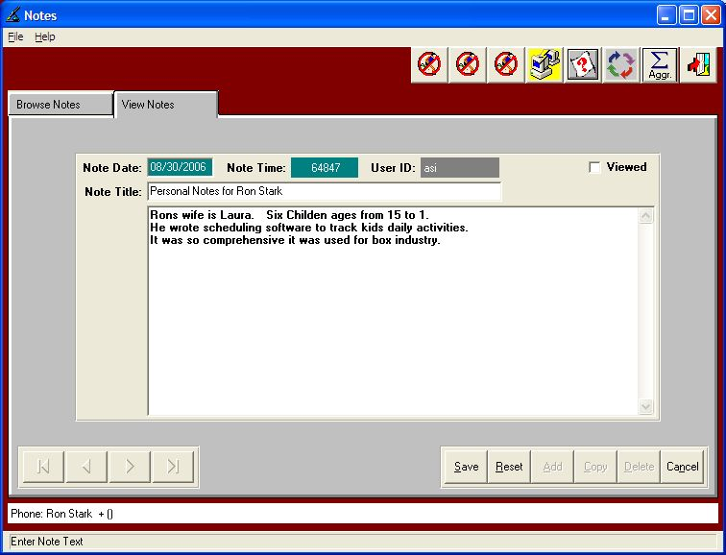

Name and Address may also be recorded, but is not necessary.

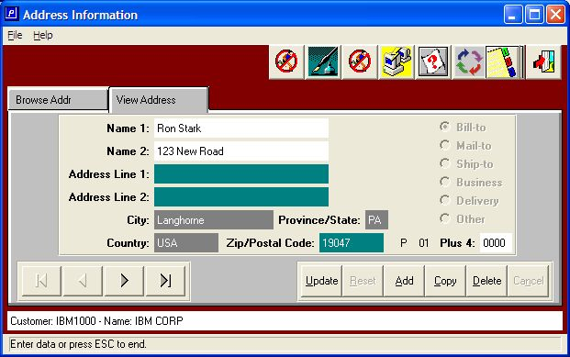
City, State and Zip for Contact must be added under system codes to add to address Icon.
